9.3 Affecting rate (Ⅰ)
Name: ____________________ Class: ____________________ Due date: 11.7
1 . Calcium carbonate reacts with hydrochloric acid to form carbon dioxide.
Which changes would slow this reaction down? （ ）
1 decreasing the concentration of hydrochloric acid
2 decreasing the particle size of calcium carbonate
3 decreasing the temperature
A 1 and 2 only B 1 and 3 only C 2 and 3 only D 1, 2 and 3

2. A student investigates the rate of reaction between zinc and an excess of sulfuric acid.
The graph shows the results of two experiments, X and Y.
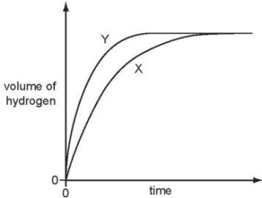
Which change explains the difference between X and Y? （ ）
A A catalyst is added in Y.
B A lower temperature is used in Y.
C Larger pieces of zinc are used in Y.
D Less concentrated acid is used in Y.

3. The rate of a reaction depends on temperature, concentration, particle size and catalysts.
Which statement is not correct? （ ）
A Catalysts can be used to increase the rate of reaction.
B Higher concentration decreases the rate of reaction.
C Higher temperature increases the rate of reaction.
D Larger particle size decreases the rate of reaction.

4. Powdered marble reacts with hydrochloric acid using the apparatus shown.
The gas syringe fills in 36 seconds.
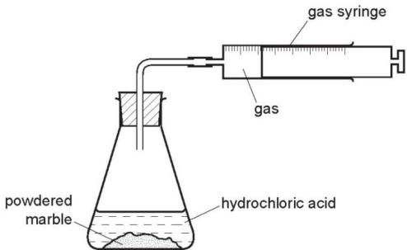
The experiment is repeated using marble chips in place of powdered marble.
How long does it take to fill the gas syringe in this experiment? （ ）
A 9 seconds B 18 seconds C 36 seconds D 72 seconds
5 .Which changes decrease the rate of reaction between magnesium and air? （ ）
1 heating the magnesium to a higher temperature
2 using a higher proportion of oxygen in the air
3 using magnesium ribbon instead of powdered magnesium
A 1,2 and 3 B 1 only C 2 only D 3 only

6. Which of the following changes decreases the rate of the reaction between magnesium and dilute hydrochloric acid? （ ）
1 diluting the acid
2 using larger pieces of magnesium
3 cooling the mixture
A 1,2 and 3 B 1 and 2 only C 1 and 3 only D 2 and 3 only

7. In an experiment nitric acid is added to excess marble chips and the volume of carbon dioxide formed is measured.
The experiment is repeated using smaller marble chips.
All other conditions remain the same.
Which statement about the second experiment is correct? （ ）
A The collisions are more frequent and higher energy.
B The collisions are more frequent and the same energy.
C The collisions are the same frequency and the same energy.
D The collisions are the same frequency and higher energy.

9. An experiment X is carried out between a solid and a solution using the apparatus shown.
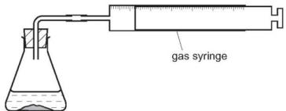
The volume of gas given off is measured at different times and the results plotted on a graph.
In a second experiment Y, the surface area of the solid is increased but all other factors remain the same.
Which graph shows the results of experiments X and Y? （ ）
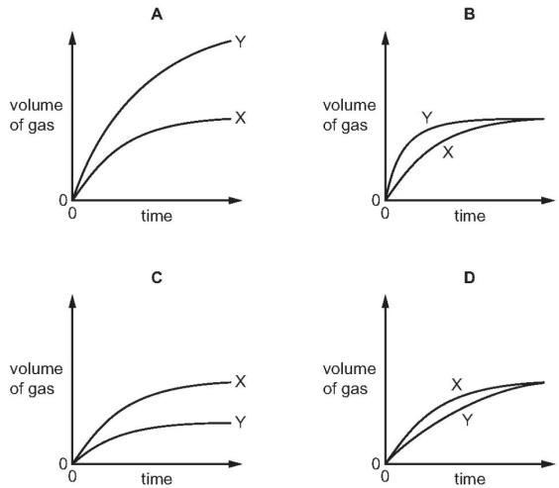
10. precipitate of insoluble sulfur is produced. This makes the mixture difficult to see through.
$${Na}_{2}S_{2}O_{3}(aq)+2HCl(aq)→S(s)+2NaCl(aq)+H_{2}O(l)+{SO}_{2}(g)$$
The time taken for the cross to disappear from view is measured.
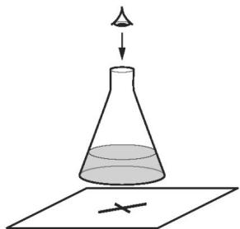
A student adds the following volumes of aqueous sodium thiosulfate, dilute hydrochloric acid and distilled water to the conical flask.
The time taken for the formation of the precipitate of sulfur to make the cross disappear from view is recorded.
experiment number | volume of sodium thiosulfate /cm³ | volume of hydrochloric acid /cm³ | volume of distilled water /cm³ | time taken for cross to disappear from view/s
1 | 10 | 10 | 40 | 56
2 | 20 | 10 | 30 | 28
3
In experiment 3 the student wanted the sodium thiosulfate to be double the concentration used in experiment 2.
(a). Complete the table to show the volumes which should be used and the expected time taken for the cross to disappear from view in experiment 3. [2]

(b). Use collision theory to explain why increasing the concentration of sodium thiosulfate would change the rate of reaction.
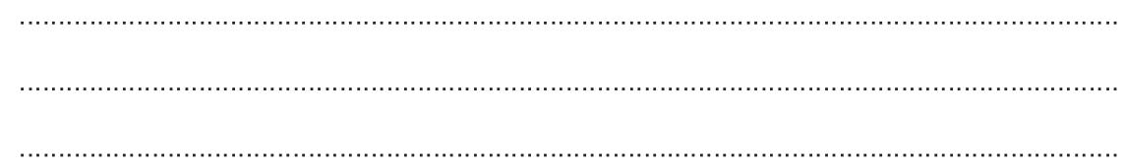

(c). The student repeated experiment 1 at a higher temperature.
Use collision theory to explain why the rate of reaction would increase.
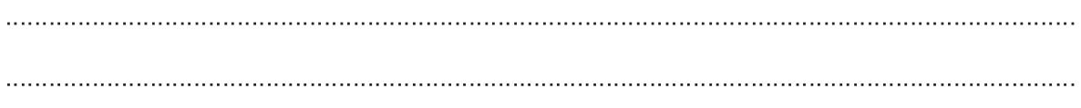

11.$20.0g$ of small lumps of calcium carbonate and $40cm^{3}$ of hydrochloric acid, concentration $2.0mol/dm^{3}$ were placed in a flask on a top pan balance. The mass of the flask and contents was recorded every minute.
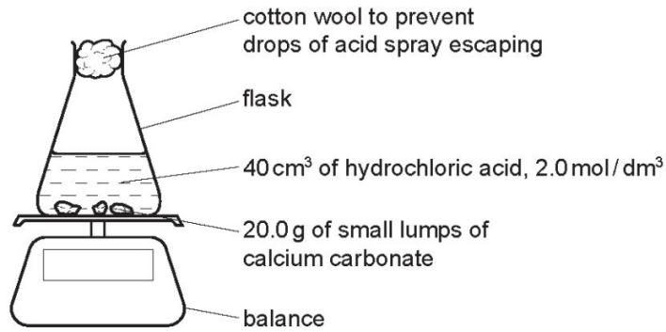
The mass of carbon dioxide given off was plotted against time.
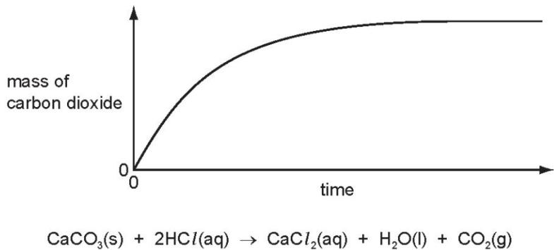
Sketch on the same graph, the line which would have been obtained if $20.0g$ of small lumps of calcium carbonate and $80cm^{3}$ of hydrochloric acid, concentration $1.0mol/dm^{3}$ had been used.

(a).Explain in terms of collisions between reacting particles each of the following.
The reaction rate would be slower if $20.0\text{g}$ of larger lumps of calcium carbonate and $40{\text{cm}}^{3}$ of hydrochloric acid, concentration $2.0{\text{mol / dm}}^{3}$ , were used.
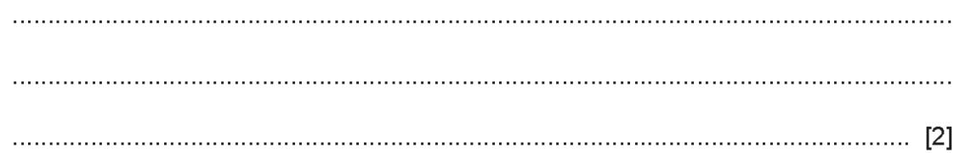
(b).The reaction rate would be faster if the experiment was carried out at a higher temperature.
